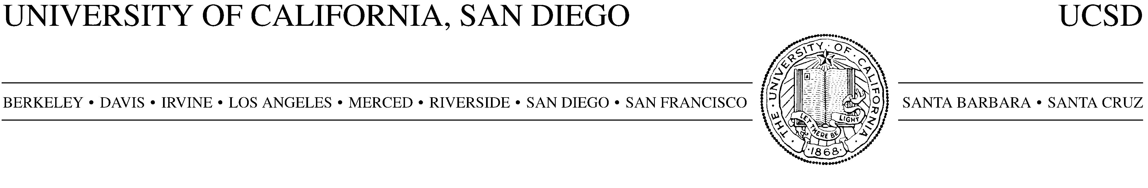
AMENDMENT NO. to AGREEMENT #

This Amendment Number [insert amendment number] to the Agreement by and between The Regents of the University of California on behalf of the University of California, San Diego (“UCSD”) and (“Company”) executed on [insert original agreement execution date] (“Agreement”) hereby revises the agreement of the parties as follows:

- The purpose of this Amendment is to extend the end date of the Agreement from [insert original end date] to [insert new end date, no more than two years later] to allow for completion of the previously agreed-to services.

This Amendment is effective as of its execution by Company. Except as modified by this Amendment, the Agreement terms and conditions remain unchanged and the Agreement remains in full force and effect.

Signature below of Company’s authorized representative represents acceptance of this Amendment and its terms.

COMPANY

By: ___________________________________
Name: __________ ______
Title: ________________ ____________

Date: _________________________________

